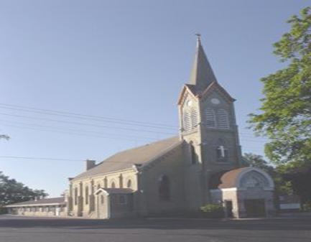
August 2026Newsletter

Email-stpaulscascade@hotmail.com
Website-www.stpaulslcmscascade.com
Church Office 528-8094
Pastor Richard M. Bidinger 528-8881
Katherine Arbuckle -Organist
Jen Schneider- Church Secretary 980-2057

Worship Times:
Sunday 8:30am Thursdays 6:30pm


And you, who once were alienated and hostile in mind, doing evil deeds, ²¹And you, who once were alienated and hostile in mind, doing evil deeds, ²²He has now reconciled in His body of flesh by His death, in order to present you in order to present you
holy and blameless and above reproach before Him,
²³if indeed you continue in the faith, stable and steadfast, not shifting from the hope of the Gospel that you heard, which has been proclaimed in all creation under heaven, and of which I, Paul, became a minister.
— Colossians 1:21-23

A Son, A Sinner and the Judge
A man was found guilty of a violent crime, The day arrived for the guilty man to be sentenced by the judge for his crime. The proceedings were delayed a few moments, and finally the man was brought in before the judge. As the judge began to speak and ready to pronounce the sentence to be served by the criminal, the door in the back of the court swung open and a young boy walked down the aisle toward the judge. The eyes of everyone in the court had turned to look to see who had entered the room. The judge looked at the boy, and with a grin spoke to him, “Son, I’m running a little late today. Go in my office and wait for me. When I’m done, we’ll go to the movie.”

The same man, but not the same relationship. The man guilty of a violent crime stood before the judge to be sentenced. The son stood before his father ready to enjoy going to the movies with his dad.

Pardoned and at Peace
The city of Colossae was located in Asia Minor (the country of Turkey today). The people of that city had never known the Scriptures or anything about God’s Word or God’s Law. The culture was shaped by the Greek and Roman religious beliefs of a Pantheon of gods with very depraved moral practices. The apostle Paul described the Greco-Roman culture, reaching back to the generations after the Flood that turned away from the true God and turned to false gods and worshiped idols.

²²Claiming to be wise, they became fools, ²³and exchanged the glory of the immortal God for images resembling mortal man and birds and animals and creeping things. ²⁴Therefore God gave them up in the lusts of their hearts to impurity, to the dishonoring of their bodies among themselves, ²⁵because they exchanged the truth about God for a lie and worshiped and served the creature rather than the Creator, Who is blessed forever!
-- Romans 1

As the apostle Paul wrote the Christians at Colossae, He was writing to those who had renounced the false gods and idols of the culture, along with its depraved and immoral practices, and through faith in Christ as their Savior, had received a pardon for their sins, and received the credit for Jesus’ righteous life. In the opening of his letter to the Colossian Christians, the apostle Paul wrote: ¹Paul, an apostle of Christ Jesus by the will of God, and Timothy our brother, ²To the saints and faithful brothers in Christ at Colossae: Grace to you and peace from God our Father. Notice that Paul addressed the Colossian Christians as “Saints”. Also notice the greeting from Paul: “Grace to you and peace from God our Father!” The “Saints” had God’s “Grace”. The Father looked upon them as “sons”! The “Saints” enjoyed “Peace”, trusting that they would never face God as Judge.

Before the Colossians knew about Christ, before the Colossians believed in Christ, Paul reminded them of the time they were guilty sinners, “²¹And you, who once were alienated and hostile in mind, doing evil deeds,…”, as he then goes on to assure them of their deliverance from sin in Christ, ²²He has now reconciled in His body of flesh by His death,
The Colossian Christians lived under Grace and therefore had Peace from God the Father!

Now, as they lived as “Saints” in an evil culture, they must hold fast to Christ and displaying God’s image, knowing that when Jesus returns and the judgment of all mankind takes place they will be “sons” standing before their “Father”!

in order to present you holy and blameless and above reproach before Him, ²³if indeed you continue in the faith, stable and steadfast, not shifting from the hope of the Gospel that you heard, The work of Christ, in living a righteous life for us and in bearing the guilt for the sins of the world is the foundation of the Christian hope and confidence.
Yes, as Christians we are “swimming in filthy, dirty water” but we must never “drink” that water—never letting it into our minds or influence our words or actions!

What a Blessing! To live under Grace, have Peace and be a “son” of our Heavenly Father!

Calendar Dates to Remember
Sunday, August 2: Worship 8:30 am Monday, August 3: Book Study 4:30pm, Board of Elders 6:30pm Wednesday, August 5: Info for Bulletins due by 12p, Pictorial Directory mtg 5pm Thursday August 6 :Worship 6:30 pm w/HC, Board of Education 7:30pm
Sunday, August 9: Worship 8:30 am Monday, August 10: Book Study 4:30pm, Board of Elders 7:30 pm Wednesday, August 12:Info for Bulletins due by 12p Thursday, August 13:LWML Meeting 10:00 am, Worship 6:30 pm w/HC
Sunday, August 16: Worship 8:30 am Monday, August 17: Book Study 4:30pm, Board of Stewardship 6pm Wednesday, August 19: Info for Bulletins due by 12p Thursday, August 20:Worship 6:30 pm w/HC Friday, August 21: NEWSLETTER DEADLINE
Sunday, August 23** Special Service Time** 160th Church & Pastor’s 40th Anniversaries. 10:00am Luncheon to follow Monday, August 24: Book Study 4:30pm Wednesday, August 26:Info for Bulletins due by 12p Thursday, August 27: Worship 6:30 pm w/HC
Sunday, August 30: Worship 8:30 am Monday, August 31: Book Study 4:30pm



Our Homebound members
Sherry Carolan is residing at Rocky Knoll, Plymouth. Lee Curtiss is residing at Gables on the Pond, RL. Dulley Deall is residing at Gables on the Pond, RL. Jim Habeck is residing at his home. Dave Hartmann is residing at Progressive, Sheboygan.
Marion Hefter is residing with family in Plymouth. Loretta Jung is residing at her Silver Creek home. John Lederer resides at his home in Adell. Keith Long is residing at Songbird Pond, Plymouth. Doris Krahn is residing at Waterford, Plymouth.
Karen Marquardt (mother of Lynn) is residing at Plymouth Care Center. Louella Raabe is residing at her home in Plymouth. Cola Schneider residing at Pine Haven, Sheb. Falls. Brenda Schultz at her home outside of Cascade.
Mary Trakel is residing at Rocky Knoll, Plymouth. Jim Wright is residing at his home.

Those members that are actively serving in the Military
Clayton Bauer stationed in Japan
Wyatt Laport stationed in Oceanside, CA

If you are interested in sending a card to our homebound or those serving in the military, please contact Jen or Pastor.
Jen and Pastor’s contact information can be found on the front of the newsletter.
Some of the individuals would love to come to church, but are unable to drive, if you would be interested in picking them up for a service, please contact Pastor.



1 Nancy Rosche
Gabe Meredith
11 Emily Melius
12 Jeffrey Seider
Timothy Block
Jennifer Schneider
13 Matthew Schultz
14 Levi Melius Jr.
16 Todd Triebensee
Jennifer Taylor
19 Sherry Carolan
20 Cheyenne Kowalczyk
24 Brooke Wegner
25 ViVina Falk
27 Kimberly Czerwinski
29 Alyssa Schultz
31 Mary Lou Curtiss

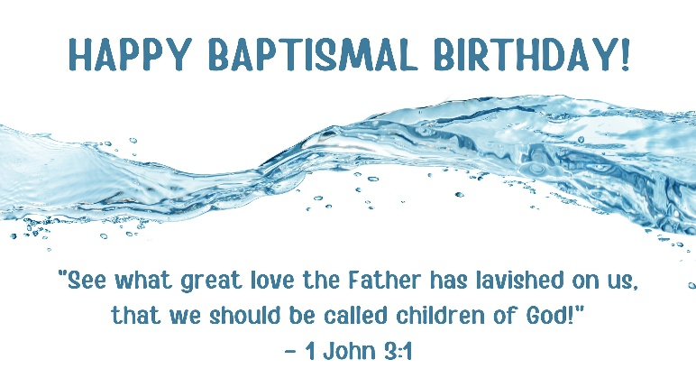

Lisa Truitt August 1, 1976
Peggy Wiehr August 7, 1963
Braxley Leonard August 24, 2022
Jacob Block August 28, 2011



Ron & Lisa Truitt as they
celebrate 6 years on August 1st.
Kyle & Abigail Beger as they
celebrate 13 years on August 3rd.
Anthony & Shannon Bliesner as they
celebrate 17 years on August 8^{t.}

Mark & Peggy Wiehr as they
celebrate 30 years on August 10th.

Robert & ViVina Falk as they
celebrate 45 years on August 15th.

Larry & Martha Rosche as they celebrate 18 years on August 16th.

Francis & Michelle Arbuckle as they celebrate 22 years on August 21st.

Mark & Kathryn Jeske as they celebrate
43 years on August 26th.

Robert & Bonnie Fieber as they celebrate
44years on August 27Th.


(St. Paul’s Youth group)
50+ Bags Project

Need ideas for 50+ Bags? August collection is stuffing and mashed potatoes.
Of course, feel free to donate as the Holy Spirit leads! Please watch expiration dates, trying to find food with at least a year out before expiration.
Collection boxes are in the Fellowship Hall and in the back of church!
But the wisdom from above is first pure, then peaceable, gentle, open to reason, full of mercy and good fruits, impartial and sincere.
James 3:17

Wanna know about St. Paul’s Awesome Youth Group???
Here’s More Info:
Whether you are shy or an outgoing person, Youth group is for YOU! It is a great way for you to get out there and further connect with not only our church but our community too! We do many different projects, and activities that shine the brightness of God’s love for each and every one of us! I think we can all agree that is what our world needs these days. All kids in grades 5-12 are encouraged to join, whether you just show up a few times, or to everything we do!
**INTERESTED IN JOINING- please contact:
Mrs. Bidinger jbidinger5@gmail.com

St. Paul's LWMLis collecting the following Gifts from the Heart items for the LWML- SWD Fall Retreat held Sept. 25-26. All Women of LCMS are encouraged to attend this Holy Spirit, Sister in Christ event. If you cannot attend, and would like to donate to our cause, see below the list of items that are being collected. Last day to donate is Thursday Sept. 24th in the labeled baskets in the entryway of church & the upper fellowship hall If you would like to contribute through offering envelopes, please indicate this on the envelope. You can give by check made to St. Paul’s Cascade LWML and put in offering plate and we will shop for you or can visit Amazon using the QR code below.
Gifts from the Heart is being collected for The Crossing of Manitowoc County: A Christian Pregnancy and Parenting Education Center and can be put in the labeled baskets in the front of church and in the fellowship Hall.

• Newborn Hand Covers • Newborn Bottle Nipples • Newborn Outfits • Onesies • Newborn Socks • Newborn Hats • Angled Peri Bottles • Nursing Pads • Sanitary Pads
• Disposable Underwear • Ice Pack Pads • Shower Streamers • Tucks/Witch-hazel Pads • Nitrile Gloves • Ultrasound Gel



Thank you, St. Paul's Cascade LWML

Why LHS?
Sheboygan Lutheran High School is committed to Preparing Christian Leaders- One Student at a
Time. Rooted in Biblical foundations, we offer a high school experience that goes above and beyond a traditional diploma.

Enrollment for the 2026-2027 is now open. Contact them at 920.452-3323 for a tour or to learn more about:
- Christian leadership
- Academic & Extracurricular programs
- Tuition & Financial assistance

SAVE THE DATE

LHS Sunday September 27th – More details to come in next newsletter




Upcoming August Sales

July 28- August 1 Linens 50% off
August 4-8 Shoes 50%
August 11 Everything in store 30% off
August 12-14 Kitchen items 50%off
August 15 NATIONAL THIFT STORE DAY 50% off everything in the store
August 18-22 Books 50% off
August 25-29 Toys, Games, Puzzles, Dolls 50% off

Concert Event
Sheboygan Lutheran PAC
America 250 - Jason Michael Carroll Concert
Sunday, August 30 | 5 pm

Celebrate the red, white, and blue with country
music star and Marine Corps veteran, Jason
Michael Carroll! Enjoy a patriotic afternoon
with an acoustic concert featuring Jason's hits
Westward Road is only here for this performance in Sheboygan County before continuing the tour.

Tickets for event available at lutheranhigh.com/pac


The Bookmobile will be stopping at
St. Paul’s Thursdays August 6th & 20th
11:45a- 12:30p

See www.monarchlibraries.org
for full schedule

Hello from Great Marriages…
I hope you are doing well and enjoying the summer season. I wanted to send a reminder of some of our upcoming events and opportunities here at Great Marriages.
Our Widow to Widow group meets on the second Thursday of each month at 10:00 here at our Great Marriages office.
This is a wonderful group of women who are at all stages of widowhood and enjoy fellowship and conversation. If you know anyone who would like to join, please let us know.

Upcoming Events

Just You & Me: A Marriage Retreat
- Cedar Valley Retreat Center
When was the last time you gave your marriage the time and attention it truly deserves? A moment to celebrate what’s working well and gently tend to the areas that could use a little extra care?
Join us for our annual Marriage Retreat, featuring Jeff Prentice and Marissa Jensen Prentice of Prentice Emotional Health Consulting. Jeff and Marissa will be guiding you through the Compassion Method; a self-compassion and emotional-healing process that uses triggers as clues, helps you comfort the pain beneath them, and aims to help you live from a calmer, more authentic self rather than from old wounds. Framed through the lens of your marriage, this retreat will help you gain practical tools to strengthen your marriage and grow closer together.
Join us for a weekend to strengthen your marriage, savor delicious meals, and create fun, lasting memories. Your next chapter of love and connection is waiting.
Location: Cedar Valley Retreat Center, 5349 Co Rd D, West Bend, WI 53090
Session times are Friday: 6:00pm-8:30pm and Saturday:9am-4:00pm

Help Us Recruit Mentor Couples
We are still seeking couples who have been married for 10+ years and have a heart for helping other couples build strong, healthy marriages. Mentor couples play a vital role in encouraging, supporting, and walking alongside couples who desire to strengthen their relationships.
If you are interested, I would greatly appreciate your referrals. I would be happy to meet personally with any interested couples to answer questions and share more about the mentor role.
Blessings,
Olivia
Olivia Simenz-Zeman
Executive Director
www.great-marriages.org
director@great-marriages.org
office: 920.783.6142
direct: 920.400.0684

